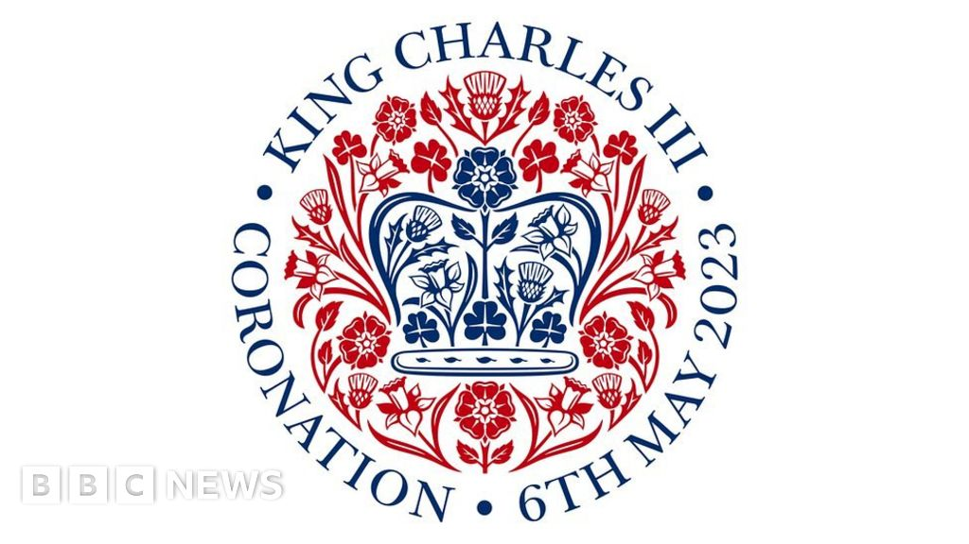

KING CHARLES III CORONATION

Celebration Picnic Party on 6th May

At 3.30pm at OLD Mill House Pub Garden
(Coronation shown on TV in pub all day.)
Children dress up in your best or fancy dress!
Parents /adults bring your picnic tea and be ready for some fun!
Maypole for dancing round. Decorate a royal crown and coronation spoon!
Games - Croquet with slight twist & throw spoon the furthest.
Lots of Prizes, Coronation Cake, and Royal toast!
Join neighbours and friends and family to celebrate!
God Save The King
